THE INFLUENCE OF BRAND IMAGE, DISCOUNT PROMOTION, AND SERVICE INNOVATION ON USAGE DECISIONS AT COWORKING SPACE SUBCO INTILAND TOWER SURABAYA
Yanata Sulaiman¹ dan Helena Sidharta²
School of Business and Management, Universitas Ciputra, Citraland CBD Boulevard
E-mail: ysulaiman@student.ciputra.ac.id¹ & helena.sidharta@ciputra.ac.id²

Abstract: This research was conducted with an aim to determine the effect of brand image, discount promotions and service innovation on usage decisions. This research will discuss about Sub Co coworking space Intiland Tower Surabaya using a quantitative approach by using a method of collecting questionnaire data via the google form. To collect the research data, 19 questionnaires were distributed to respondents aged 17-60 years, namely consumers who had used Sub Co coworking space Intiland Tower Surabaya at least once with a total sample of 50 respondents. Sampling was done by purposive sampling method. The intended respondents were coworking space users within the last 3 months starting from the first of February 2023 to the end of April 2023. The measurement model in this study was analyzed using the SPSS application. Data analysis consisted of validity test, reliability test, multicollinearity test, normality test, F test, T test, multiple linear regression analysis, correlation coefficient of determination test and heteroscedasticity test. The results of the research conducted show that the brand image variable has results that have a significant positive effect on usage decisions, discount promotions have significant positive results on usage decisions, and service innovation results have a significant positive effect on usage decisions at Sub Co Intiland Tower Surabaya. This research is expected to be useful for coworking space companies and for further researchers to be able to use other variables that can influence the decision variable to obtain broader results.
Keywords: Brand Image, Discount Promotion, Service Innovation, Usage Decision
Abstrak: Penelitian ini dilakukan dengan tujuan untuk mengetahui pengaruh brand image, promosi diskon, dan inovasi layanan terhadap keputusan penggunaan. Penelitian ini akan membahas mengenai coworking space Sub Co Intiland Tower surabaya menggunakan pendekatan kuantitatif dengan metode pengumpulan data kuesioner melalui google form. Untuk mengumpulkan data penelitian, 19 kuesioner disebarkan kepada responden yang berusia 17-60 tahun, yaitu merupakan konsumen yang pernah menggunakan coworking space Sub Co Intiland Tower Surabaya minimal satu kali dengan jumlah total sampel sebanyak 50 responden. Pengambilan sampel dilakukan dengan metode purposive sampling. Responden yang dituju merupakan pengguna coworking space dalam kurun waktu 3 bulan terakhir mulai dari awal Februari 2023 sampai Akhir April 2023. Model pengukuran pada penelitian ini dianalisis dengan menggunakan aplikasi SPSS. Data analisis terdiri dari uji validitas, uji reliabilitas, uji multikolinearitas, uji normalitas, uji F, uji T, analisis regresi linear berganda, uji koefisien korelasi determinasi dan uji heteroskedastisitas. Hasil dari penelitian yang dilakukan menunjukkan bahwa variabel brand image mendapatkan hasil yang berpengaruh positif signifikan terhadap keputusan penggunaan, promosi diskon memiliki hasil yang positif signifikan terhadap keputusan penggunaan, serta hasil inovasi layanan yang berpengaruh secara positif signifikan terhadap keputusan penggunaan di Sub Co Intiland Tower Surabaya. Penelitian ini diharapkan dapat berguna bagi perusahaan coworking space dan bagi peneliti selanjutnya dapat menggunakan variabel-variabel lain yang dapat mempengaruhi variabel keputusan penggunaan untuk memperoleh hasil yang lebih luas.
Kata kunci: Brand Image, Promosi Diskon, Inovasi Layanan, Keputusan Penggunaan

INTRODUCTION
Coworking space is a building that combines the functions of a community center and office in which it offers a sharing space that can accommodate the activities of office and community actors. With the environment in Indonesia that will continue to increase every year, it creates a varied user, profession so that it can help the country's business and economic activities gradually improve.
According to a study conducted by deskmag over the past two years, the increase in coworking space users accelerated by 79%. Regarding workplace innovation, 90% of people who coworked became more confident, and 71% experienced an increase in creativity due to supportive services and flexibility. With the desire and need for consumers to use products from the office sector, the concept of brand image, discount promotions, and innovation has become an important phenomenon. A service innovation is provided by a company so that the methods applied to the work system keep up with the times to meet consumer desires (Changkaew, 2015: 6; in Dewi et al., 2021). In addition, when the product has a strong brand image in the minds of consumers, it will easily arouse and change the perspective in making usage decisions and more easily develop (Firmansyah, 2018: 87). Translated with DeepL.com (free version)
From the phenomenon of the discussion above, it is still not known for certain whether brand image, discount promotion and service innovation can affect usage decisions. Therefore, this study was conducted because the researchers wanted to find out whether the variables of brand image, discount promotion, and service innovation have a significant effect on usage decisions.

LITERATURE REVIEW
Theoretical Foundation
Brand Image
Brand image is a description of the overall perception of the brand and is formed from information and experience with the brand (Firmansyah, 2018: 87). Consumers see from the perspective of the brand as a picture of what is in the mind or consumer understanding of a brand (Saridewi, et al., 2020). According to Low and Lamb (2000: 4, in Iis Miati., 2020) said that brand image measurement can be done based on 3 indicators, namely: the brand is known by the wider community, the brand adds to the user's self-image, the brand has a distinctive image from other brands.

Discount Promotion
Kotler and Armstrong (2019, in Fathanul, 2022) state that promotion is an activity in an effort to convey product benefits and persuade customers with purchasing activities from what is offered. According to Sudaryono (2014, in Elsa et al., 2022: 3) discounts are a technique that involves offering a reduction from a certain price to promote the sale of a product or service. According to (Sutisna 2013; in Indra Ade Irawan & Islamiah Kamil., 2022) said that the measurement of promotions in the form of discounts can be done based on 4 indicators, namely: discounts provide attention, discounts have appeal, discounts arouse shopping desires, discounts encourage to make purchases.

Service Innovation
Innovation is assisted by creativity and is at the heart of the spirit of the company in playing an important role in fighting for success and creating a viable company, especially in highly competitive markets, (McLean, 2007; in Muhammad Izuwan, et al., 2019). Indicators according to Fernando Henrique Taques (2020), namely: adding benefits to existing services, both for customers new or old, implementation of improvements to procedures or services provided, introduction of new methods related to changes in services,

changes in company activities, more efficient use of assets and resources.

Usage Decision
According to Sofjan Assauri (in Nurmasari, 2019) The decision to use is a process of making purchases and uses which includes determining what to buy and choosing from previously researched activities. Meanwhile, based on Buchari (2018), it is said that the decision to use or purchase is a process where consumers recognize their problems and seek information about products or brands in order to evaluate how well the alternatives will be used to solve their problems, namely determining a decision. There are indicators of usage decisions according to Muharam & Soliha (in Reni Ernawati et al., 2021), namely: product choice, brand choice, purchase time, purchase amount, and payment method.

Previous Research
Research conducted by Reminta et al., (2020) aims to examine the effect of price and service innovation on decisions to use Express Taxi Services: Survey on Express Taxis Application Downloaders with purposive sampling method. The results showed that the independent variable service innovation had a significant effect on the dependent variable, namely usage decisions. The relationship with this study is that it has the same variables, namely the independent variable of service innovation and the dependent variable of usage decisions.
Research conducted by Andrian et al., (2020) aims to determine the effect of brand image and service quality on purchase intention and its impact on purchase decision Samsung Smartphone with purposive sampling method. The results of this study indicate that the brand image variable has a significant effect on the purchase decision variable. The relationship with this study is that it has the same variables, namely the independent variable brand image and the dependent variable purchase decisions.
Research conducted by Ngoc-Long Nguyen et al., (2020) aims to determine the effect of lifestyle, brand image, and personalities on smartphone purchase decisions on consumers in Ho Chi Minh City with a random sampling method. The results of this study indicate that the brand image variable has a significant effect on purchase decisions. The relationship with this research is that it has the same variables, namely the independent variable brand image and the dependent variable purchase decision.
Research conducted by Jalal Rajeh Hanasyah, (2018) aims to determine the factors that influence purchasing decisions in the Malaysian retail market. The results of this study indicate that independent sales promotion has a significant effect on independent purchase decisions. The relationship with this research is that it has the same variable, namely the independent variable sales promotion and the dependent variable purchase decision.

Relationship between Variables and Hypothesis
Research conducted by Ngoc-Long Nguyen et al., (2020) states that the brand image variable shows significant results on purchasing decisions. In addition, research conducted by Andrian et al., (2020) shows that the brand image variable shows significant results on purchasing decisions.
H1: Brand Image has a significant effect on Usage Decisions

Research conducted by Jalal Rajeh Hanasyah (2018), states that the sales promotion variable shows significant results on purchase decisions. In addition, research conducted by Wang et al., (2021) states that the discount promotion variable has a significant effect on purchase decision.
H2: Discount Promotion has a significant effect on Usage Decision

Research conducted by Dewi et al., (2021) states that the service innovation variable has significant results on purchasing decisions. In addition, research conducted by Reminta et al., (2020), shows that the service innovation variable has significant results on usage decisions.
H3: Service Innovation has a significant effect on Usage Decisions

Conceptual Framework
Figure 1. Conceptual Framework
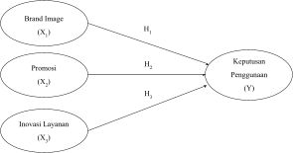
Source: Data processed, 2023

RESEARCH METHODOLOGY
This type of research is quantitative research. The population of this research is consumers who have used coworking space products Sub Co Intiland Tower Surabaya as many as 50 people obtained from users from the beginning of February 2023 to the end of April 2023 within a period of 3 months which will be studied through distributing questionnaires. The customer in question is obtained from visitor data that has been recorded in the system, and who is on the spot. The sampling technique used purposive sampling. The criteria for the sample in this study are:
- Sub Co Intiland Tower Surabaya coworking space customers aged 17-60 years.
- Customers who have used the coworking space Sub Co Intiland Tower Surabaya in the last 3 months, namely at the beginning of February 2023 until the end of April 2023.

Variables and Operational Definitions
Table 1. Variables and Operational Definitions
Variable | Operational Definition of Variables | Source
Brand Image (X1) | Brand image is seen from the perspective of the brand as a picture of what is in the mind or consumer understanding of a brand. | Saridewi et al., 2020
Discount Promotion (X2) | Promotion in the form of discounts is one part of the marketing mix and not only functions as a communication tool but as a process that influences between buyers and sellers in purchasing activities or using services with wants and needs. | Buchari Alma (2013, in Hurriyati, 2018)
Service Innovation (X3) | Service innovation is able to encourage companies to turn environmental changes into an opportunity. | Yulianto & Hasan (2019: 5; in Reminta et al., 2020)
e Decision (Y) | The decision to use or purchase is a process where consumers recognize their problems and seek information about products or brands in order to evaluate how well the alternatives will be used to solve their problems, namely determining a decision. | Buchari (2018)
Source: Data processed, 2023

Data Analysis Method
Data collection and data sources in this study used primary data through the use of questionnaires with online distribution via google form. The research will choose a lift based on a Likert scale, namely with 5 scales, namely: Strongly Agree (SS) has a score of 5, Agree (S) has a score of 4, Moderately Agree (CS) has a score of 3, Disagree (TS) has a score of 2, and Strongly Disagree (STS) has a score of 1.

DATA ANALYSIS AND DISCUSSION
Data Analysis
Researchers will use SPSS to analyze this research data obtained through questionnaires. SPSS is used to explain whether there is a relationship between the independent variables of brand image, discount promotion, and service innovation on the dependent variable of usage decisions through validity testing; reliability test; classical assumption test with normality test using One Sample Kolmogorov Smirnov, heteroscedacity test, multicollinearity test, F test, t test, multiple linear regression analysis, and correlation and determination coefficients.

Discussion
Validity Test
Table 2. Validity Test
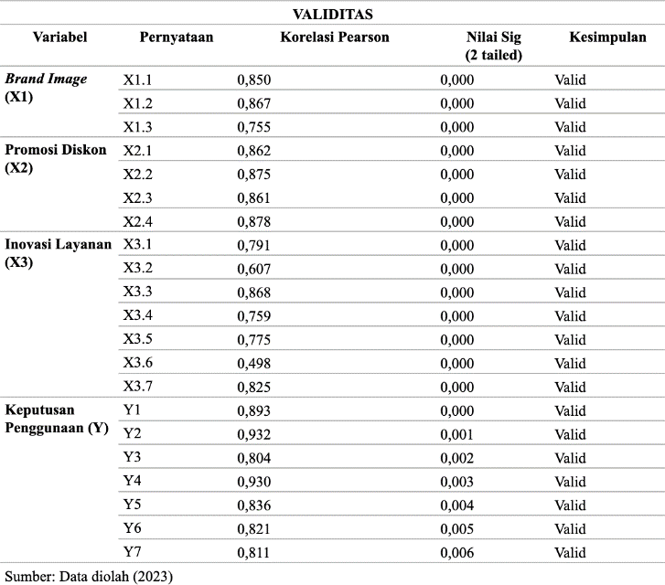
Source: Data processed, 2023

The validity test is used to measure a real thing, whether a questionnaire is valid or not. The validity test describes the accuracy of the indicators used in the questionnaire as seen from the significance value <0.05. The validity test results in table 2, the variable item statements of brand image, discount promotion, service innovation, and usage decisions, each show a significance value <0.05 so it can be interpreted that the statements on the questionnaire are valid.

Reliability Test
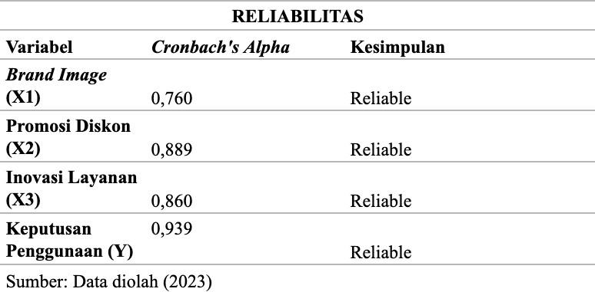
Table 3. Reliability Test
Source: Data processed, 2023

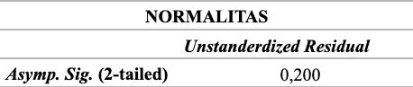
The Cronbach's Alpha result for the brand image variable is 0.760, for the discount promotion variable is 0.889 followed by the service innovation variable of 0.860 and the usage decision variable of 0.939. The Cronbach Alpha coefficient shows that the variables in the study must be> 0.6 to be said to be reliable (Suharsimi, 2018). All variables in this study have a coefficient> 0.6, so the conclusion on the variable indicators of this study is reliable.
Classical Assumption Test
Table 4. Normality Test

Source: Data processed, 2023

The normality test results are carried out to determine whether the independent and dependent variables or both are normally or abnormally distributed which is seen through the One Sample Kolmogorov Smirnov test from a significance value> 0.05. Based on table 4, it shows that the significance value of the One Sample Kolmogorov Smirnov test is 0.200, which means that the significance value is> 0.05. So it can be concluded that the data is normally distributed.

Multicollinearity Test
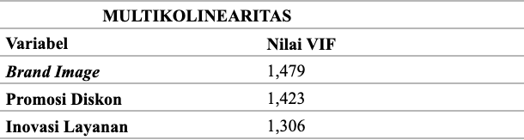
Table 5. Multicollinearity Test
Source: Data processed, 2023

The multicollinearity test is seen from the VIF value, if the VIF value < 10 then, there is no multicollinearity. Based on table 5, it shows that the VIF value is <10, where the brand image variable has a value of 1.479, for discount promotion has a value of 1.423, and service innovation has a value of 1.306. From these results it can be concluded that there is no multicollinearity between the brand image, discount promotion and service innovation variables.

Heterokesdaticity Test
Table 6. Heterokesdaticity Test
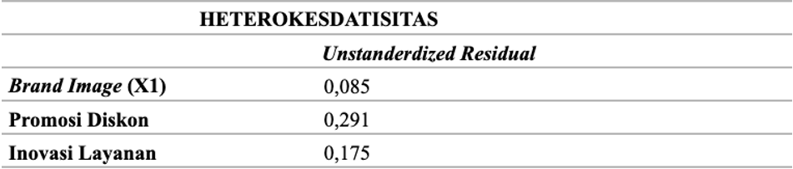
Source: Data processed, 2023

Hypothesis Test
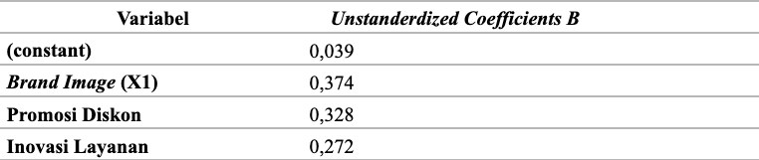
Table 7. Multiple Linear Regression Analysis
Source: Data processed, 2023

Y = 0.039 + 0.374 X1 + 0.328 X2 + 0.272 X3
Through the constant value, it can be interpreted that the value of variable Y is 0.039. It can be assumed that the value of the brand image variable (X1), discount promotion (X2), and service innovation (X3) is constant. A positive Y value indicates that customers desire a usage decision at the Sub Co Intiland Tower Surabaya coworking space.
The brand image variable has a positive value of 0.374. This shows that if the brand image variable is fixed, then every one unit increase, the value of the usage decision variable will increase by 0.374 to 0.413. From these results it can be concluded that if the brand image variable (X1) increases, the usage decision variable (Y) will also increase.
The discount promotion variable has a positive value of 0.328. This shows that if the promotion variable is fixed, then for every one unit increase, the value of the usage decision variable will increase by 0.328 to 0.367. From these results it can be concluded that if the discount promotion variable (X2) increases, the usage decision variable (Y) will also increase.
The service innovation variable has a positive value of 0.272. This shows that if the service innovation variable is fixed, then every one unit increase, the value of the usage decision variable will increase by 0.272 to 0.311. From these results it can be concluded that if the service innovation variable (X3) increases, the usage decision variable (Y) will also increase.

F test
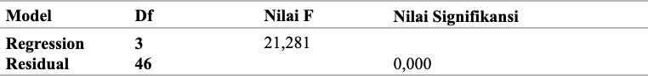
Table 8. F test
Source: Data processed, 2023

The F test is tested simultaneously whether the two independent and dependent variables both influence each other or not. Based on table 8 shows that the result is 0.000 <0.05. This value is feasible and acceptable for predicting the level of usage decisions where brand image variables, discount promotions and service innovation affect usage decisions at the Sub Co Intiland Tower Surabaya coworking space.

t test
Table 9. t test
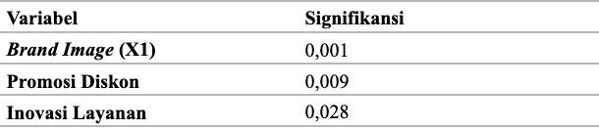
Source: Data processed, 2023

In the t test research, if the significance> 0.05, there is no influence from the independent variable to the dependent, but if the significance value <0.05, there is an influence from the independent variable and the dependent variable. Based on Table 9, it shows that the brand image variable has a significance value of 0.001, for discount promotions it has a significance value of 0.009, and service innovation has a significance value of 0.025. The results of the significance value in the three variables show <0.05 so it can be concluded that the brand image variable, discount promotion, and service innovation have a significant effect on the usage decision variable. From the significance value, it can be seen that the variable that has a strong influence on usage decisions is brand image. So it can be concluded that H1, H2, and H3 are accepted.

Correlation Coefficient (R) and Coefficient of Determination (R²)
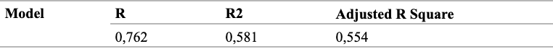
Table 10. Correlation Coefficient (R) and Coefficient of Determination (R²)
Source: Data processed, 2023

The coefficient of determination is a multiple regression result that shows how much the dependent variable can be explained by the independent variable. Based on table 10, it shows that the R value is 0.762, which means that there is a relationship between the independent and dependent variables. the coefficient of determination used in this study is adjusted R square, which means that 55.4% of the variables in this study affect usage decisions, and the remaining 44.6% is influenced by variables not included in the study.

Research Implications
Based on this research, the brand image variable has a significant effect on usage decisions. Consumers who have made transactions at the Sub Co Intiland Tower Surabaya coworking space feel that brand image is an important factor in encouraging use. The brand must be conveyed and known well to customers. In addition, broad recognition must also be added so that knowing the Sub Co brand widely can encourage use in the Sub Co Intiland Tower Surabaya coworking space.
The next result in this study is the discount promotion variable which has a significant influence on usage decisions. Consumers feel that discount promotions are an important factor in encouraging use in the Sub Co Intiland Tower Surabaya coworking space. The discount promotion feature can make it easier for consumers to get additional information and prices that are more friendly and in accordance with the target. In addition, the frequency and duration of discount promotions must also be considered in making promotions. A duration that is not too long and the right frequency of discount promotions can encourage usage at the Sub Co Intiland Tower Surabaya coworking space.
The results of this study also concluded that the service innovation variable has a significant effect on usage decisions. Consumers feel that service innovation is an important factor in encouraging use in the Sub Co Intiland Tower Surabaya coworking space. Changes in terms of service innovation can provide more comfort and make it easier for customers to access the Sub Co coworking space area. In addition, the frequency and pattern of innovation must also be considered if there are improvements in terms of service innovation. The frequency of innovation and the right pattern of innovation can encourage use in the coworking space Sub Co Intiland Tower Surabaya.
In this study, the three variables have a significant influence in increasing usage in the coworking space Sub Co Intiland Tower Surabaya. Therefore, coworking space Sub Co Intiland Tower Surabaya must be able to pay attention to brand image variables, discount promotions and service innovation to increase consumer usage to continue to grow.

CONCLUSIONS AND SUGGESTIONS
Conclusions
Brand Image has a significant effect on usage decisions. Discount promotions have a significant effect on usage decisions. Service innovation has a significant effect on usage decisions.

Suggestions and Limitations
Coworking space Sub Co Intiland Tower Surabaya is advised to carry out broader brand recognition so as to increase customer confidence in recognizing the brand and its entire product, in terms of service innovation with more innovation, customers can increase comfort while working and be able to choose varied services. Another thing that can be improved by coworking space Sub Co Intiland Tower Surabaya is the duration and frequency of appropriate discount promotions that can increase customers' desire to use continuously.
It is recommended that future researchers can use other independent variables such as price and service quality which also lead to positive behavioral intentions in increasing consumer usage decisions. Therefore, in future studies, price and service quality variables can be added to test their influence on the usage decision variable. Future research can also use different research objects such as the Go Work coworking space. Respondents in this study were also found to be not too broad, so it is recommended that further research can make the necessary changes.
The limitation of this research is because most coworking space users are not every day in Sub Co Intiland Tower Surabaya so that the questionnaire distribution is done online. Online distribution causes a slow response from respondents.

REFERENCES
Batu, R. L., Suryani, N. I., Septia, N., & Sekaryahya, P. F. (2020). Pengaruh Harga dan Inovasi Layanan Aplikasi terhadap Keputusan Penggunaan Jasa Taksi Express: Survei pada Pengunduh Aplikasi Express Taxis. Jurnal Nasional Manajemen Pemasaran & Sdm, 1(1), 1-22.
Deskmag. (2022). 2022 Coworking Space Business Trends. Retrieved May 12, 2023, from https://www.deskmag.com/en/coworking-news/2022-results-of-the-coworking-space-business-trends-survey?limitstart=1
Ernawati, R., Dwi, A. B., & Argo, J. G. (2021). Analisis Pengaruh Promosi, Harga, dan Citra Merek terhadap Keputusan Pembelian pada Situs E-Commerce Zalora Di Jakarta. Business Management Analysis Journal (Bmaj), 4(2), 200-218.
Hanaysha, J. R. (2018). An Examination of The Factors Affecting Consumer’s Purchase Decision in The Malaysian Retail Market. Psu Research Review, 2(1), 7-23.
Hutagalung, E. A., Turnip, K. P., Terok, Z. Y. S., & Sibarani, H. J. (2022). Analisis Pengaruh Kualitas Layanan, Diskon Harga dan Promosi Produk Terhadap Keputusan Pelanggan dalam Menggunakan Layanan Aplikasi Grab di Kota Medan. Management Studies and Entrepreneurship Journal (MSEJ), 3(3), 1125-1138.
Irawan, I. A., & Kamil, I. (2022). Keputusan Pembelian pada Marketplace Tokopedia Ditinjau dari Pengaruh Faktor Promosi Penjualan, Brand Image, dan Harga. Jurnal Perspektif Manajerial Dan Kewirausahaan (Jpmk), 2(2), 9-18.
Mazla, M. I. S. B., Jabor, M. K. B., Tufail, K., Yakim, A. F. N., & Zainal, H. (2020, September). The Roles of Creativity and Innovation in Entrepreneurship. In International Conference on Student and Disable Student Development 2019 (ICoSD 2019) (pp. 213-217). Atlantis Press.
Miati, I. (2020). Pengaruh Citra Merek (Brand Image) terhadap Keputusan Pembelian Kerudung Deenay (Studi Pada Konsumen Gea Fashion Banjar). Abiwara: Jurnal Vokasi Administrasi Bisnis, 1(2), 71-83.
Musikasari¹, D. E. W. I., Saputri, D., Sari, D. R., Hartini, S., & Ekawaty, N. (2021). Pengaruh Bundling Produk dan Inovasi Layanan 4.5 G terhadap Keputusan Pembelian pada Xl Pascabayar.
Nguyen, N. L., Tran, T. T., & Vo, M. P. (2020). The Effect of Lifestyle, Brand Image And Personalities on Smartphone Purchase Decision of Consumers In Ho Chi Minh City. International Journal Of Innovative Science And Research Technology, 5(3), 481-492.
Nurmasari, I. (2019). Pengaruh Citra Perusahaan, Motivasi Konsumen, dan Persepsi Konsumen terhadap Keputusan Penggunaan Jasa Jahit (Studi pada Butik Munja Griya Busana di Jepara) (Doctoral Dissertation, Unisnu Jepara).
Starda, M. A. B., Dahda, S. S., & Widyaningrum, D. (2022). Pengaruh Kualitas Layanan, Promosi, Brand Ambassador, dan Citra Merek terhadap Keputusan Konsumen Menggunakan Jasa J&T Express Gresik Menggunakan Metode Regresi Linier Berganda. Justi (Jurnal Sistem Dan Teknik Industri), 2(2), 278-289.
Tannady, H., Sjahruddin, H., Saleh, I., Renwarin, J. M., & Nuryana, A. (2022). Role of Product Innovation and Brand Image toward Customer Interest and Its Implication on Electronic Products Purchase Decision. Widyakala Journal, 9(2), 93-98.
Taques, F. H., López, M. G., Basso, L. F., & Areal, N. (2021). Indicators used to measure service innovation and manufacturing innovation. Journal of Innovation & Knowledge, 6(1), 11-26.
Wang, C., Wang, Y., Wang, J., Xiao, J., & Liu, J. (2021). Factors Influencing Consumers’ Purchase Decision-Making In O2o Business Model: Evidence From Consumers’ Overall Evaluation . Journal of Retailing And Consumer Services, 61,102565. Https://Doi.Org/10.1016/J.Jretconser.2021.102565

