Energy Efficiency Enhancement on Universitas Ciputra Surabaya: Greenship Parameters Based

Albert Jonathan Tandiaryª, Jason Santoso^{b}, Amellisa Billienda Mertadana^{c}, Susan^{d}, Maureen Nuradhi^{e}
^{a/b/c/d/e}Architecture Department, School of Creative Industry, Universitas Ciputra,
Surabaya, Indonesia

Corresponding Email: susan@ciputra.ac.id^{d}

ABSTRACT

The increasing global demand for energy, particularly in the building sector, has underscored the need for effective energy efficiency management, as buildings account for a significant portion of the world’s energy consumption. In Indonesia, energy consumption has been increasing, with projections indicating a continued rise due to population and economic growth. Universities are significant energy consumers due to their diverse needs and numerous activities. The rapid expansion of higher education, particularly in countries like Indonesia, exacerbates energy demand. This research examines the Universitas Ciputra Surabaya Tower as a case study for EEC implementation, based on Greenship parameters as defined by the Green Building Council Indonesia (GBCI). The research aims to assess the extent of Universitas Ciputra’s efforts in improving its energy efficiency and conserving energy from renewable resources. Several efforts have been made, including the implementation of solar panels and the use of energy-efficient lighting and HVAC units. The results have shown that these applications have conserved approximately 2-3% of renewable resources and reduced energy consumption over the last few years. Hence, as the point calculation set by Greenship parameters, Universitas Ciputra Tower has already reached a total of 33 out of 36 points in the EEC rating tools.

Keywords: Energy Efficiency, Greenship, Renewable Resources, Solar Panel, Universitas Ciputra

INTRODUCTION
The existence of energy has become crucial as the key source of operational activities in buildings and many other sectors. Where data indicates that buildings consume one-third of the world’s energy (Srinivasan, R.S., et al., 2012), as the world’s fourth-largest producer of coal and Southeast Asia’s largest supplier of gas, Indonesia must raise its awareness on these issues. Indonesia’s electricity consumption has shown an increase of 4% per year, reaching 289 TWh in 2023 (42% of households, 27% of services, and 31% of industry) (Enerdata, 2023). Data suggests that electricity demand will increase by 4.8% to 5.3% between 2023 and 2060. Indonesia surely couldn’t resist this demand, as its population and economy are expected to grow significantly each year (IRENA, 2022). Hence, to respond to the needs, Indonesia has set a target by 2025 to have at least 23% of renewable energy in the mix of other energy sources. Indonesia is also aiming to be a net-zero emission country by 2060.

As the largest country in the Association of Southeast Asian Nations in several categories, Indonesia’s population is expected to rise to 335 million people over the next three decades. It will surely impact the number of building users, including office complexes, schools, universities, and public buildings.

College buildings are considered one of the primary energy consumers, as they typically have laboratories that require a higher amount of energy than regular classrooms. The amount of attention being devoted to college buildings has been increasing rapidly recently, as each university strives to expand its educational footprint. Although it is crucial for people to receive proper education, it also has an impact on energy consumption. For instance, in 2021, over 44 million students were enrolled in higher education in China (Ministry of Education of the People’s Republic of China, 2021). Studies also indicate that each student’s energy consumption is four times the national average (Zhang, F., & Ruan, Y., 2009). This condition surely requires several actions to overcome the challenges that education has brought in this time and the next several years. There has been an argument, such as the implementation of regulations as one of the requirements for building permits, focusing on conserving energy and improving its efficiency. It surely would work on new buildings; however, it applies differently to existing buildings, which require adjustments and dynamic changes to the building’s elements. Although it is challenging to use this strategy on existing buildings, local governments in Indonesia, such as Jakarta, Surabaya, Bandung, and Makassar, are currently developing a system to monitor these issues (Azizi, N., et al., 2018).

Regarding this matter, independent institutions like the Green Building Council Indonesia (GBCI) have developed several rating tools to assess buildings, one of which is the Energy Efficiency and Conservation (EEC) tool. There are 6 rating tools in this criterion. This rating tool is used as a parameter set by GBCI to raise awareness and motivate society about the importance of using renewable energy, maximizing energy conservation, and improving energy efficiency.

Universitas Ciputra Tower is one of many educational buildings that have adopted and implemented the green building concept, as established by the Green Building Council of Indonesia (GBCI). Universitas Ciputra has also made a significant contribution to GBCI by being one of the funders of its many events. Each year, the number of students at Universitas Ciputra has increased rapidly due to its expansion in terms of majors, scholarships, and educational quality, both nationally and internationally. Hence, Universitas Ciputra’s management department has the obligation to monitor the energy usage of its citizens on a routine basis. Furthermore, to ensure the source of the energy comes from renewable energy or in a way that has successfully achieved energy conservation from building components. Therefore, this research aims to demonstrate that Universitas Ciputra possesses the necessary abilities and resources to meet the Greenship Energy and Conservation criteria.

METHODS
This research examines the extent to which Universitas Ciputra Surabaya’s operations align with energy efficiency and conservation (EEC) based on Greenship parameters. Universitas Ciputra Tower Surabaya was chosen as a case study due to its commitment to being a sustainable building, aiming to be an EEC building role model in the education sector, having structured campus facilities, easily accessible data, and its location in a tropical region, making it relevant to addressing environmental challenges in Indonesia.

This research method involves systematic steps, namely:
- Identification and Data Collection
  - Primary data was obtained through direct observation of campus facilities, including lighting, ventilation, and renewable energy systems.
  - Secondary data consists of literature studies on EEC concepts, GBCI regulations, and campus technical documents.

- Building Analysis
The analysis encompasses the implementation of passive strategies, including building orientation, natural lighting, and cross ventilation, as well as the evaluation of active technologies, such as HVAC systems, energy-efficient lighting, and solar panels.

3. Comparative Studies
Comparing the results of EEC implementation at Universitas Ciputra with national standards determined by the Green Building Council Indonesia (GBCI).

4. Integration of Theory into Operational Methods
  - Drawing on energy modeling and sustainability assessment theory, this research employs a quantitative approach to measure energy savings and reductions in carbon emissions.
  - Relevant theory quotes, such as “Energy Efficiency is a key pillar of sustainability” (Smith, 2020), are used to support analytical steps.

RESULT AND DISCUSSIONS
Energy Efficiency and Conservation P1 (Energy Management Policy and Plant)
In EEC P1, it serves as a prerequisite for fulfilling the next sub-rating tool category, which discusses energy management policies and plans. This benchmark refers to the discussion regarding the existence of a statement letter containing a commitment from top management to monitor savings targets and action plans over a prolonged period. Additionally, a written campaign is being implemented to encourage energy savings, featuring stickers, posters, and emails.

Universitas Ciputra Tower itself does not yet have established policies in the form of SOPs and concrete actions for saving energy. However, Universitas Ciputra has implemented and provided stickers near the light plugs as an effort to save electrical energy.

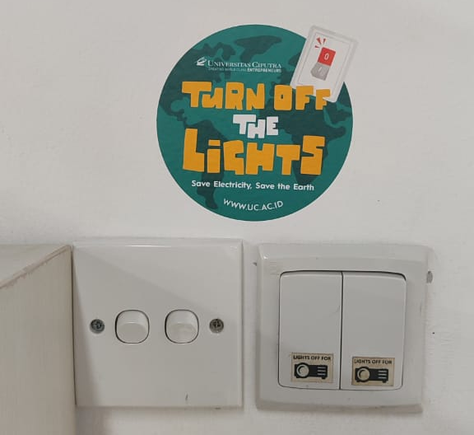
Figure 1. Electricity Saving Sticker on Floor 17th

Source: Private Document, 2024

Energy Efficiency and Conservation P2 (Minimum Building Energy Performance)
In this EEC P2 point, it discusses the electrical IKE standard in a building, which has been observed over the last 6 months and is now smaller than the reference standard electrical IKE determined by GBC Indonesia. UC Surabaya is categorized under the Office category, with a standard of 250 kWh/m²/year.

Apart from that, it discusses energy savings of 5% or more, comparing the average energy consumption of the last year with that of the previous year. For this category, if UC Surabaya can provide the requested data, points shall be given.

Table 1. IKE Electricity Data for 2018-2019

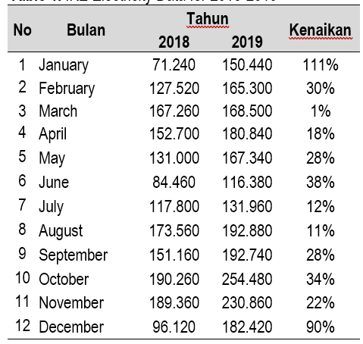

Source: Researcher’s Analysis, 2024

Based on this data, in 2018-2019, it can be concluded that the average IKE calculation in 2018 produced a figure of 137.7 kWh. On average, IKE produced 177.84 kWh in 2019.

Apart from that, Ciputra University Surabaya has solar panels located on top of the building, which are capable of producing 2-3% of renewable energy.

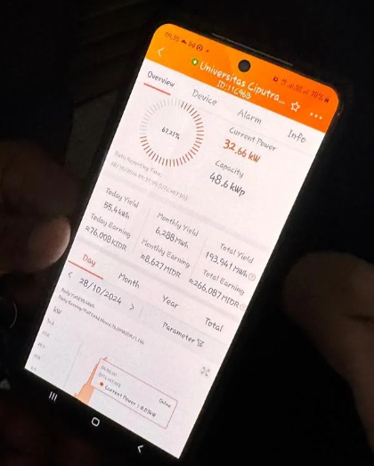

Figure 2. Existing Energy Detection Application

Source: Private Document, 2024

From the results of the data and calculations above, it can be concluded that the average value of electricity IKE at Universitas Ciputra Tower is below the Electric IKE standard, specifically 250 kWh/m², with values of 137.7 kWh in 2018 and 177.84 kWh in 2019. Thus, Universitas Ciputra Tower has fulfilled the prerequisites to continue and has also met other sub-rating tools.

Energy Efficiency and Conservation 1 (Optimized Efficiency Building Energy Performance)

EEC point 1 discusses the electrical IKE standards in a building, as observed over the last 6 months, with the average results required to be less than or equal to 120% of the standard. For the first category, every 5% decrease and subsequent decreases will result in an additional 1 point, up to a maximum of 8 points. For the second category, if the electricity IKE value is shown to be below the reference standard, then for every 3% decrease, you will get 1 point up to a maximum of 16 points.

Table 2. IKE Electricity Data Table for 2018-2019

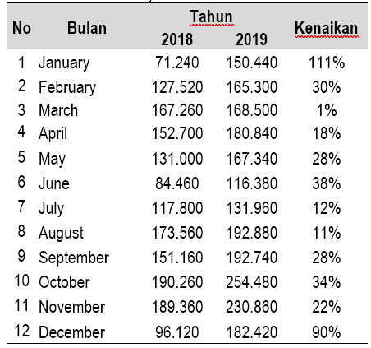

Source: Researcher’s Analysis, 2024

Based on data obtained in 2018-2019, if the data is taken and averaged from January to June in 2019, the calculation will produce a figure of 158,133 KWH.

Table 3. Earning IKE Electric Points

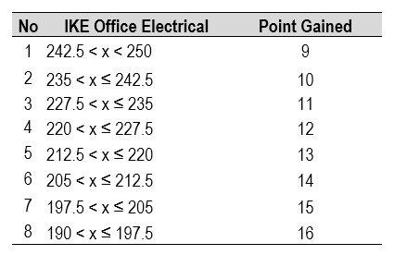

Source: Researcher’s Analysis, 2024

From the results of the calculations above, it can be concluded that the average value of electricity at Universitas Ciputra Tower is below the Electric IKE standard, namely 190 kWh, with a value of 158,133 kWh. This results in Universitas Ciputra Tower receiving the maximum points, namely 16 points, with a continuous decrease of 3%.

Energy Efficiency and Conservation 2 (Energy Management Policy and Plan)

At EEC point 2, we discuss re-commissioning or retro-commissioning activities, which are carried out periodically, typically once a year, to enhance the overall performance of MVAC equipment, such as chillers, AHUs, and pumps. If this successfully fulfills these criteria, 2 points will be awarded.

At Universitas Ciputra Surabaya, the university has carried out routine re-commissioning activities, conducted every three months, on all MVAC equipment. There is evidence of cooperation, as well as commissioning letters that have been carried out.

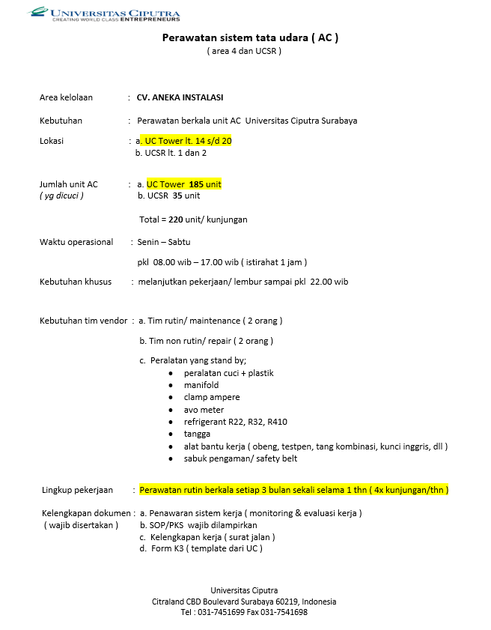

Figure 3. AC Maintenance Cooperation Letter with CV. Various Agencies

Source: Researcher’s Analysis, 2025

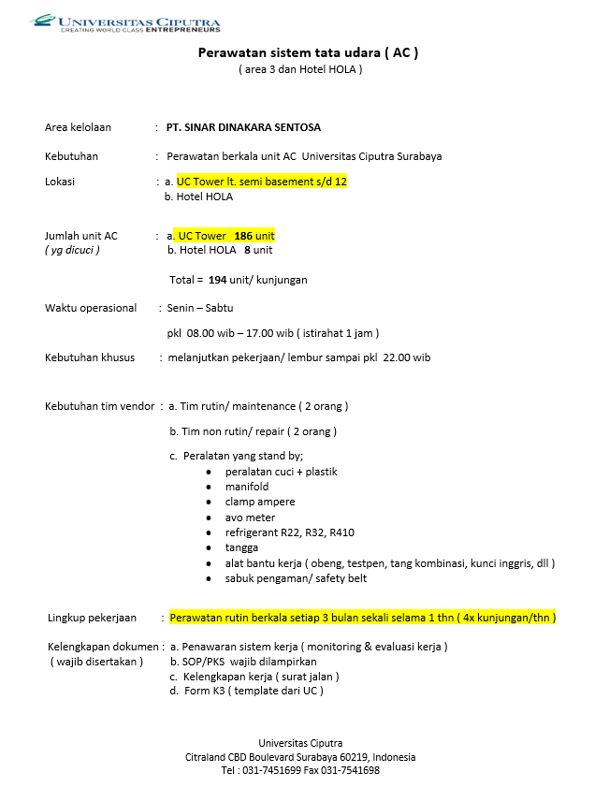

Figure 4. AC Maintenance Cooperation Letter with PT. Sinar Dinakara Sentosa

Source: Researcher’s Analysis, 2025
With this evidence, Ciputra University gets 2 points because it carries out commissioning activities once a year.

Energy Efficiency and Conservation 3 (System Energy Performance)

In EEC point 3, the discussion focuses on evaluating the energy performance of the building's system, which includes the operational efficiency of central energy systems (such as HVAC, lighting, and electrical equipment). This evaluation is conducted by monitoring energy performance over the past six months to ensure compliance with efficiency standards. If this successfully fulfils these criteria, you will get a maximum of 12 points.

Ciputra University Surabaya has reduced energy consumption in room lighting, saving 20% more than the lighting power stated in SNI 03-6197-2000 concerning Energy Conservation in Lighting Systems. Ciputra University Surabaya no longer uses ballast lamps and has been replaced with LED lamps with energy-saving specifications.

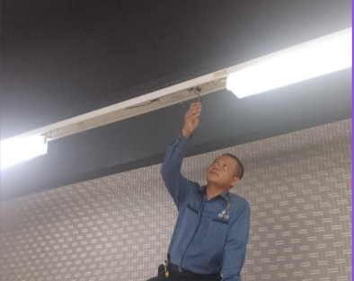

Figure 5. Installation & Use of LED Lights Source: Private Document, 2024

Apart from that, Ciputra University Surabaya has also carried out efficiency measures for equipment that uses an electric-operated Air Conditioning system, so the minimum efficiency according to GBC Indonesia and its savings efforts are as follows:

Table 4. AC System Savings Efficiency Standards

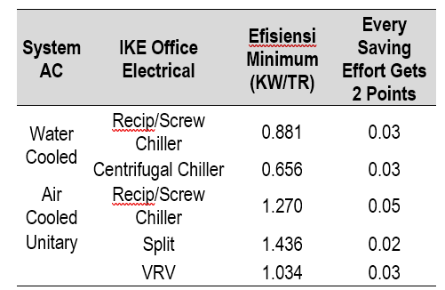

Source: Researcher’s Analysis, 2024

Ciputra University utilizes a VRV system with a media supply in the form of ducting, consisting of cassette and wall-mounted indoor units. The Daikin product application, which incorporates energy-saving specifications, helps to meet the standard of AC savings as set by GBC Indonesia.

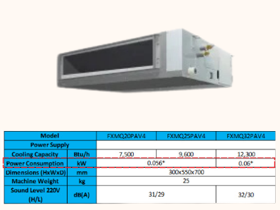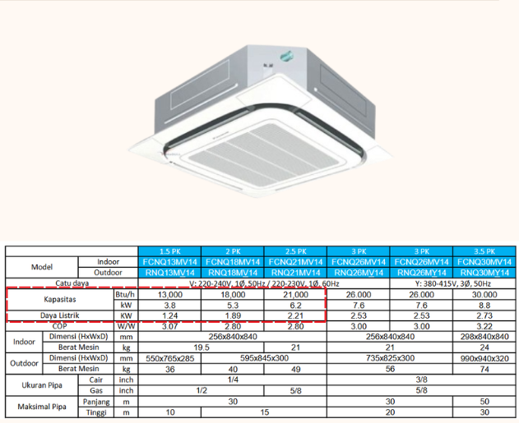

Figure 6. AC Cassette and Mounted Duct Specifications

Source: Daikin.com

Thus, Ciputra University will get a maximum of 12 points because it has used energy efficient lighting and ventilation equipment.

Energy Efficiency and Conservation 4 (Energy Monitoring & Control)

This EEC 4 point has quite a lot of subpoints, including:
- Providing KWH meters for air systems, light, contact boxes, etc.
- A routine is in place for recording KWH meter data monthly, which is carried out for six consecutive months.
- Providing information in the form of energy displays, which include energy savings and consumption from year to year.
- Using technology in the form of EMS (Energy Management System), which is used to monitor and control equipment
- Conduct an external energy audit (level 2) at least once a year.

If the five criteria above are met, you will get a maximum of 3 points.

In point 1, Universitas Ciputra Tower still has not used and distributed KWH meters according to the requested criteria.

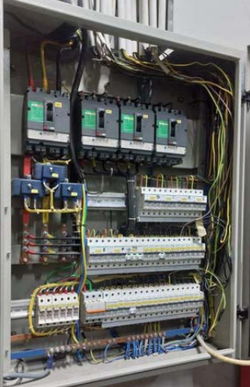
Figure 7. Main Panel Contains KWH Meter Distribution
Source: Private Document, 2024

In point 2, Universitas Ciputra Tower has carried out routine records both weekly and monthly. This recording is done using an application that is able to detect every energy that comes in and out.

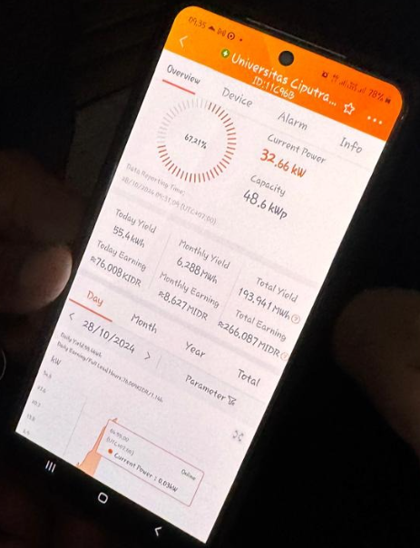
Figure 8. Existing Energy Detection Application
Source: Private Document, 2024

In point 3, Universitas Ciputra Tower still does not provide facilities in the form of displays that explain energy savings and consumption. Meanwhile, for points 4 and 5, Universitas Ciputra Tower has not yet utilized digital technology (EMS) in monitoring and controlling, and there is no cooperation with external parties in energy recording.

Based on the results of the observations above, Ciputra University meets only one of the five criteria, so it receives only one point. Therefore, there is a need for a new solution that can help Ciputra University get the maximum points, namely 3 points

Energy Efficiency and Conservation 5 (Operation And Maintenance)

At EEC point 5, we will discuss reports and maintenance guidelines for AC systems, including chiller, air handling unit, cooling tower, vertical transportation equipment (such as gondolas), clean and dirty water distribution systems (pumps), and backup power plants (gensets). Apart from that, having evidence of all operations in the form of reports and SOPs is also very important for regular monthly recording. If all the criteria are met, a maximum of 3 points will be awarded.

Universitas Ciputra Tower already has the data and reports that are in accordance with the operation and maintenance standards applied to AC systems, such as chillers, air handling units, and cooling towers.

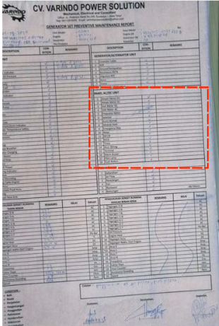
Figure 9. Universitas Ciputra Tower AC Maintenance Report
Source: Private Document, 2024

Additionally, Universitas Ciputra Tower has implemented routine maintenance for lifts, gondolas, generators, and other equipment. The maintenance operation is performed by a third party, which is selected by Universitas Ciputra whenever maintenance requests arise. However, the routine reports have not been written in a document or table form.

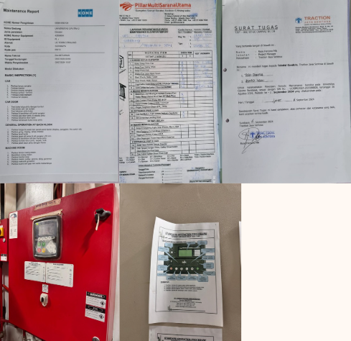
Figure 10. Universitas Ciputra Tower Maintenance Report for Lifts, Gondola, and Generators
Source: Private Document, 2024

In the third criterion, namely providing formats for SOPs and regular reports, Universitas Ciputra Surabaya still lacks definite formats, SOPs, and regular reporting procedures. There are only files and cooperation reports from external parties that help. Thus, Universitas Ciputra only received 2 out of 3 points, so it requires improvement to maximize the missing points.

Energy Efficiency and Conservation 6 (On Site Renewable Energy)

At EEC Point 6, we will discuss the use of equipment capable of producing and conserving other energy into renewable energy. If you succeed in achieving 0.25% of the maximum power demand from renewable energy, you will receive 1 point. For every subsequent decrease of 0.5%, you will gain an additional 1 point, up to a maximum of 5 points, corresponding to 2% of the maximum power demand that can be generated.

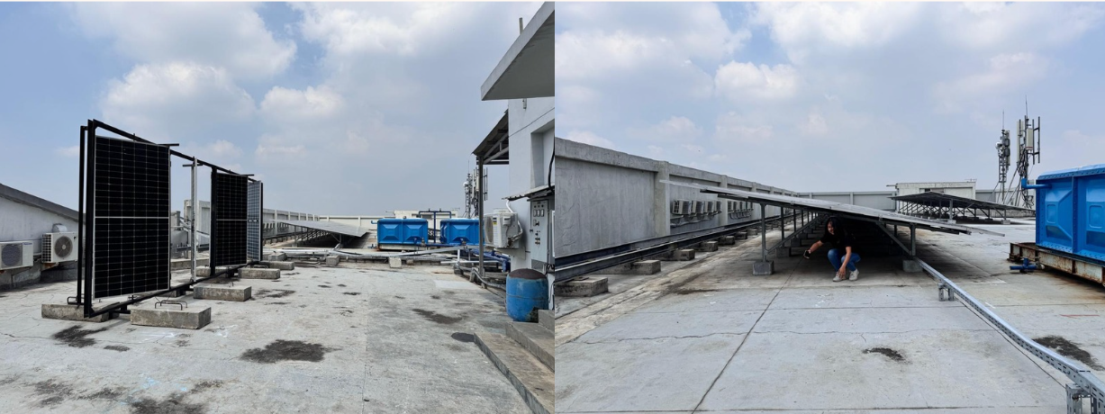
Figure 11. Solar Panels Located on the Rooftop of Universitas Ciputra
Source: Private Document, 2024

Universitas Ciputra Tower has implemented and used solar panels since 2019, which are capable of converting solar energy into electrical energy. The impact provided by these solar panels is capable of producing 2% to 3% of the total energy demand as renewable energy. Although it is undoubtedly a remarkable step, Universitas Ciputra has concerns about its consumption. Nevertheless, the amount of conserved energy can be increased each year as the number of energy demands continues to rise due to the increasing number of students and university citizens. Thus, Ciputra University gets a maximum of 5 points.

Energy Efficiency and Conservation 7 (Less Energy Emission)

At EEC Point 7, we discuss reducing CO2 emissions from their sources. Usually, this CO2 is produced from the use of electrical energy from PLN. To reduce these emissions, you can utilize renewable energy sources such as wind, water, solar power, and others.

Universitas Ciputra Tower itself has an application that can track and detect every increase and decrease in CO2.

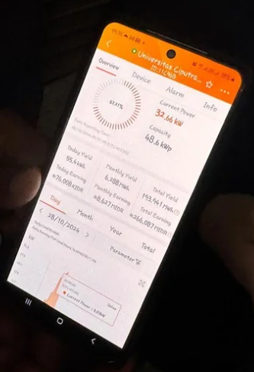
Figure 12. Detector Display For CO2 Reduction Source: Private Document, 2024

According to the report on Universitas Ciputra Tower’s energy consumption from January to December 2019, the average is 177.845 MWH/year.

Table 5. Calculation of CO2 Percentage Reduction from 2018 -2019
Category | Energy Consumption (mWh/year) | Conversion (tCO2 mWh) | CO2 Emission (tons/year)
Baseline | 177.84 | 0.891 | 158.46
Universitas Ciputra | 174.29 | 0.891 | 155.29
Difference |  |  | 3.17
Percentage |  |  | 2%

Source: Researcher’s Analysis, 2024

Based on the calculations carried out, it can be concluded that Universitas Ciputra Tower can reduce CO2 emissions by 2%, equivalent to 3.17 tons/year. This is due to Universitas Ciputra Tower’s solar panel implementation, which conserves solar energy and produces 2-3% of its energy. Thus, Ciputra University receives the maximum point, namely 3 points, because it succeeded in reducing CO2 emissions by more than 1%.

Solution & Strategy
Based on the results of the observations and analysis above, several categories of rating tools from the EEC still do not receive maximum points. To address the shortage of points, it is necessary to have a solution that can increase the missing points.

Letters and SOPs for All Documents

Ciputra University can create a document containing all SOPs and distribution letters for all policies and regulations related to routine maintenance and records for energy conservation. This letter can be distributed via email, WhatsApp, and other media.

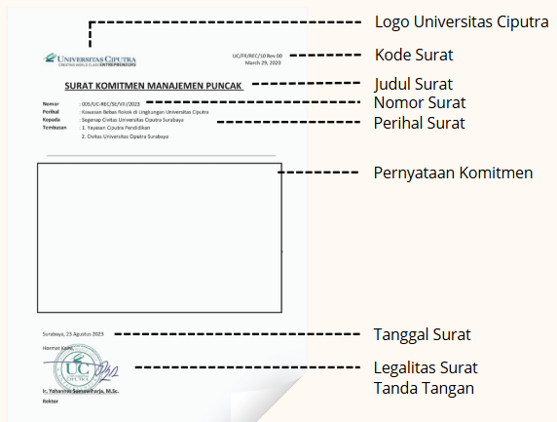
Figure 13. Example of Top Management Commitment Letter in Energy Saving
Source: Private Document, 2024

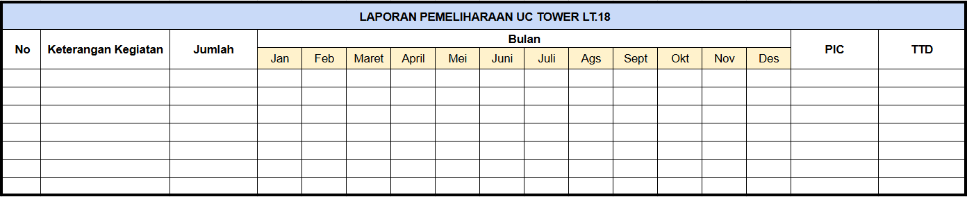
Figure 14. Example of a Maintenance Report Template
Source: Private Document, 2024

Energy Saving Poster

To maximize energy savings, posters, stickers, and other infographics can be created with an energy-saving context and placed in strategic areas, such as the Corepreneur, Elevator, etc.

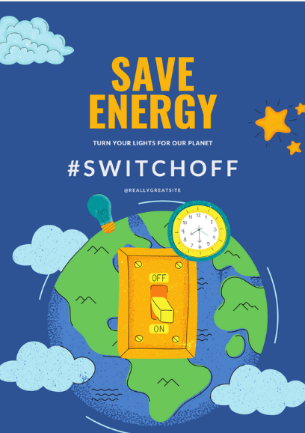
Figure 15. Example of an Energy Saving Poster
Source: Private Document, 2024

Infographic For Energy Savings & Consumption

Ciputra University can create infographics that contain all the information on energy usage and savings for a one-month period. This can take advantage of media such as television, which is available in several areas, including the main lobby, conference rooms, elevators, and others.

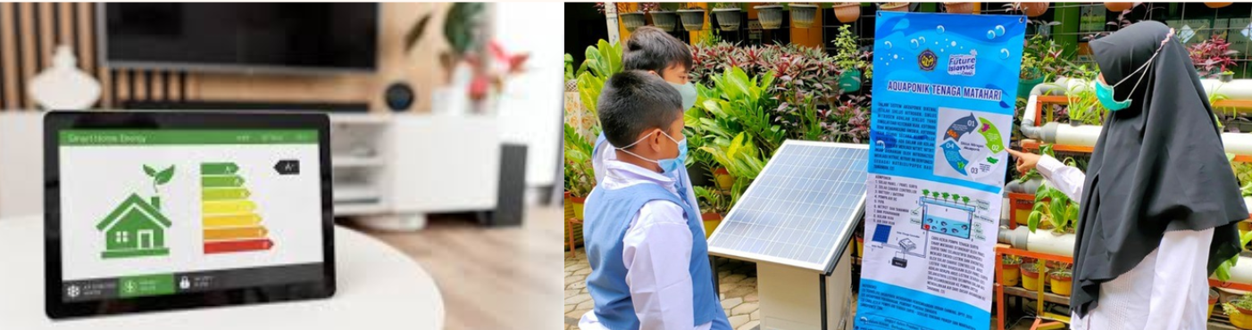

Figure 16. Examples of Information on Energy Savings and Consumption in Infographic Form

Source: Tempo.com,2024

Apart from that, to maximize routine maintenance and checking, you can utilize technology such as AI and IoT and collaborate with professional institutions, including the Energy Conservation Certification Institute (LSKE), the Indonesian Energy Auditors Association (IAEI), and other relevant organizations.

KWH Meters Section

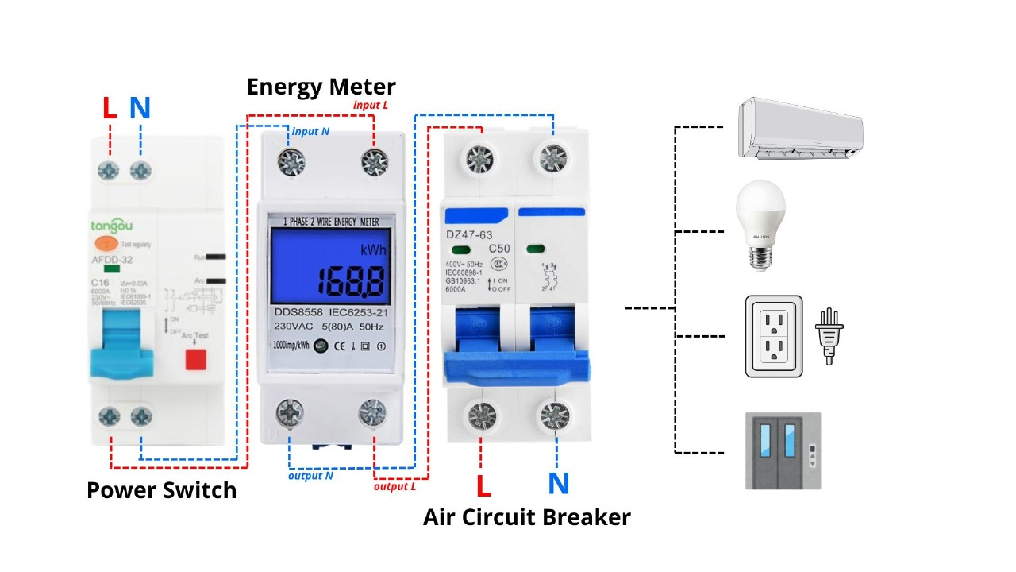

Figure 17. Division of KWH Meters

Source: Researcher’s Analysis, 2024

The university can use a strategy of providing and distributing KWH meters according to its needs, for example, for AC, lights, lifts, etc. This is done to provide limits and observe the distribution of the largest amount of electricity, as well as what is not.

Calculation Results

Table 6. Overall Point Calculation Results
No | Category | Point Max | Point Gained | Simulated Point Gained
1 | EEC P1 | P | - | -
2 | EEC P2 | P | P | -
3 | EEC 1 | 16 | 16 | 16
4 | EEC 2 | 2 | 2 | 2
5 | EEC 3 | 12 | 12 | 12
6 | EEC 4 | 3 | 1 | 3
7 | EEC 5 | 3 | 2 | 3
8 | EEC 6 | - | 5 (Bonus) | -
9 | EEC 7 | - | 3 (Bonus) | -
TOTAL |  | 36 | 33 | 36
PERCENTAGE |  | 30.77% | 27.35% | 30.77%

Source: Researcher’s Analysis, 2024

Based on the analysis carried out above, the points obtained from Tower Universitas Ciputra still do not meet the maximum points provided by the GBCI EEC standard rating tools. The points obtained from Tower Universitas Ciputra were only 33 out of 36. However, after being given several solutions as described above, the missing points could be corrected again.

CONCLUSION

Overall, the assessment of the energy efficiency component at Universitas Ciputra Surabaya has successfully met most of the assessment criteria set by the Green Building Council Indonesia (GBCI). The implementation of energy efficiency measures, such as the use of environmentally friendly materials, efficient cooling systems, and the management of natural and artificial lighting, is in accordance with the parameters determined by GBCI.

With a holistic approach, Universitas Ciputra can become a model for a green education campus, responding to the tropical climate in Indonesia, supporting sustainable development goals, and promoting energy efficiency as part of its modern education vision.

REFERENCES
Azizi, N., Achmad, B., Faridah, Kencanawati, E., Utami, S.S. (2018). Energy Monitoring System for Existing Buildings in Indonesia. EDP Science: ASTECHNOVA 2016.
Brown, A., & Wilson, R. (2019). "Passive Design Strategies for Tropical Climates." Sustainable Architecture Journal, 12(3), 112–128.
Doe, J., & Roe, P. (2018). "Evaluating Energy Conservation Strategies in Educational Buildings: A Case Study." Journal of Green Architecture, 15(4), 235–250. https://doi.org/10.1016/j.jga.2018.04.00
Enerdata. (2023). Indonesia Energy Information. https://www.enerdata.net/estore/energy-market/indonesia/#:~:text=Indonesia%20Power%20Consumption,2020%20and%20shifted%20to%202022
IRENA. (2022). Indonesia energy transition outlook. International Renewable Energy Agency, Abu Dhabi.
Ministry of Education of the People’s Republic of China National Education Statistical Bulletin in 2021. (2021). Available online: http://www.moe.gov.cn/jyb_sjzl/sjzl_fztjgb/202209/t20220914_660850.html
Smith, J. (2020). Principles of Energy Efficiency and Sustainability in Building Design. New York: Green Press.
Srinivasan, R. S., Braham, W. W., Campbell, D. E., & Curcija, C. D. (2012). Re (De) fining net zero energy: renewable emergy balance in environmental building design. Building and Environment, 47, 300-315.
Zhang, F., & Ruan, Y. (2009). Promote Saving Campus Demonstration Construction. Constr. Sci. Technol, 10, 16-18.

