Grand rules:
Use Arial font type
Maximum 20 pages, one column
The author(s) should proofread first the manuscript (check your grammar, etc.)
(For layout, it will be done by our team in editing process)
Do not change the font type, size, or spacing.

A title of the manuscript must be specific and effective
(16 pt, bold, center, single space & sentence case)
(capital only first character of the first letter)

Name of Author ¹, Name of Author ², Name of Author ³, etc.
(12pt, bold, align left, single space)

Affiliation¹, Affiliation², Affiliation³, etc.
(11pt, italic, align left, single space)

*Corresponding author: ..............@.............
(11pt, italic, align left, single space, please select among the author(s) and identify the corresponding author using an asterisk superscript)

 |  | ABSTRACT
Journal of Tourism, Culinary, and Entrepreneurship  e-ISSN:  2776-0928  Publisher:  School of Tourism,  Universitas Ciputra Surabaya, Indonesia  Keywords:  Keyword1  Keyword2  Keyword3  Keyword4  Keyword5  Maximum 5 keywords  Received: ???  Revised: ???  Accepted: ??? |  | (10 pt, 150-250 words, single space) The abstract should be clear, concise, and easily comprehensible by non-specialists. The abstract summarizes the main elements of the paper, preferably related to the values, purposes, methods, and findings of the study. It should not contain any references nor equations.

1. INTRODUCTION (12 pt, bold, 1.5 spacing, UPPERCASE)
Sub-heading (if any, 11 pt, bold, 1.5 spacing, capitalized first letter)
(11 pt, 1.5 spacing) This section aims to entice the reader to the core compelling aspects of the research undertaken. State the motivation of the research by highlighting key managerial and/or theoretical context being addressed in the study. Provide the theoretical underpinnings of the current research and link them to your research background. The theories presented should extend, not repeat, those that have been introduced as a background of the study. Furthermore, the results of the literature survey provide the readers with: (1) a background of the selected theories and/or concepts relevant to the current research, (2) a summary (i.e. critical evaluations, organization, and synthesis) of relevant but pertinent previous studies, and (3) a critical inquiry (agreement or disagreement with the previous theoretical positioning and/or research findings) of the summary. Therefore, a good introduction should:
- State broad theme or topic of the study
- Highlights academic and practical importance
- Cites most important prior studies and literature that are relevant to the article’s topic
- Emphasizes most important knowledge gaps, inconsistencies, and/or controversies being addressed by the current research
- Indicates the research problem/questions, specific objectives, and the context of the current research
- Literature review & hypotheses development (if an) is not written separately from introduction

2. METHODOLOGY (12 pt, bold, 1.5 spacing, UPPERCASE)
Sub-heading (if any, 11 pt, bold, 1.5 spacing, capitalized first letter)
(11 pt, 1.5 spacing) This section provides sufficient details pertaining to the design and execution of the current research as well as the justification for the use of specific research methods. The details allow both the readers and independent researchers for evaluating the reliability and validity of the findings as well for replicating the current research. The following sub-sections are typical in the writing of methods: Sampling (target population, research context, units of analysis, sampling method, respondent profile), data collection methods and processes, measures.

3. RESULTS AND DISCUSSION (12 pt, bold, 1.5 spacing, UPPERCASE)
Sub-heading (if any, 11 pt, bold, 1.5 spacing, capitalized first letter)
(11 pt, 1.5 spacing) Results should be clear and concise, which provides interpretations of the data analysis summary (descriptive and inferential). Sufficient details must cover the use and justification of certain statistical analysis as well as description and interpretation of results, the latter of which cover both the confirmed or rejected hypotheses of the current research. There are tables / figures / diagrams / parts of transcripts interview to be provided if any. Furthermore, Discussion section is placed after the results are presented and it elaborates the significance of the results for both the current and prior relevant research. Do not restate the findings reported nor add additional reports not stated earlier.

Example Table Format
Table 1. Table Title
Construct | Items | Outer Loading
Irregular Shift Work | ISW1 | 0.801
Irregular Shift Work | ISW2 | 0.832
Irregular Shift Work | ISW3 | 0.845
Irregular Shift Work | ISW4 | 0.788
Employee Engagement | EE1 | 0.844
Employee Engagement | EE2 | 0.861
Employee Engagement | EE3 | 0.838
Employee Engagement | EE4 | 0.849
Employee Engagement | EE5 | 0.834
Employee Engagement | EE6 | 0.828
Employee Engagement | EE7 | 0.817
Employee Engagement | EE8 | 0.822
Employee Engagement | EE9 | 0.836
Source: ??? (Year)

Example Figure Format
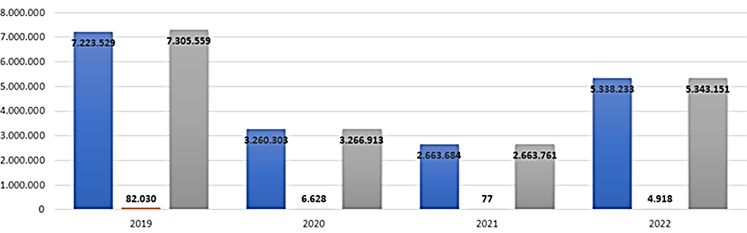
Figure 1. Figure Title
Source: ??? (Year)

4. CONCLUSION (12 pt, bold, 1.5 spacing, UPPERCASE)
(11 pt, 1.5 spacing) A conclusion section should contain the a) summary of the research, b) managerial / theoretical implication, c) limitation, and d) recommendation for future research.
5. ACKNOWLEDGEMENTS (optional, 12 pt, bold, 1.5 spacing, UPPERCASE)
(11 pt, 1.5 spacing) If there is any acknowledgement that authors would like to mention, please mention here if there are any.

6. REFERENCES (12 pt, bold, 1.5 spacing, UPPERCASE)
(11 pt, single space) Use a reference manager tool in APA Style (7th edition) format. Please add citations from 3–4 articles published in the Journal of Tourism, Culinary, and Entrepreneurship (JTCE). Only references cited within the text are included.
(11 pt, single space) Use a reference manager tool in APA Style (7th edition) format. Please add citations from 3–4 articles published in the Journal of Tourism, Culinary, and Entrepreneurship (JTCE). Only references cited within the text are included.
(11 pt, single space) Use a reference manager tool in APA Style (7th edition) format. Please add citations from 3–4 articles published in the Journal of Tourism, Culinary, and Entrepreneurship (JTCE). Only references cited within the text are included.
And so on

